Case Study

Virtual Global College (VGC),

with 3 branches in Ireland

Issues:

currently run a paper-based

**Purpose of this assignment**:

Concepts, design and implementation of a web application.

This application should be able carry out the following tasks:

* Registering of Students for courses and their ongoing attendance for courses
* Managing Student contact and personal identifying information
* Tracking of Academic Progress of students (results for assignments and exams)
* Tracking Payment of fees – including partial payments
* Tracking of Exams, Assignments and dates and results (uploading not required)

Faculty Members should be able to access details relevant to them (i.e. only their students):

* Student’s Grade Book (Assignment results)
* Student’s Attendance
* Contact detail of students for tutors only.

Students should be able to login and see all details relevant to them (except provisional exam results before being released).

It can also found on Git Hub:

<https://github.com/yogupd/collegeapplication>

# UML Diagram

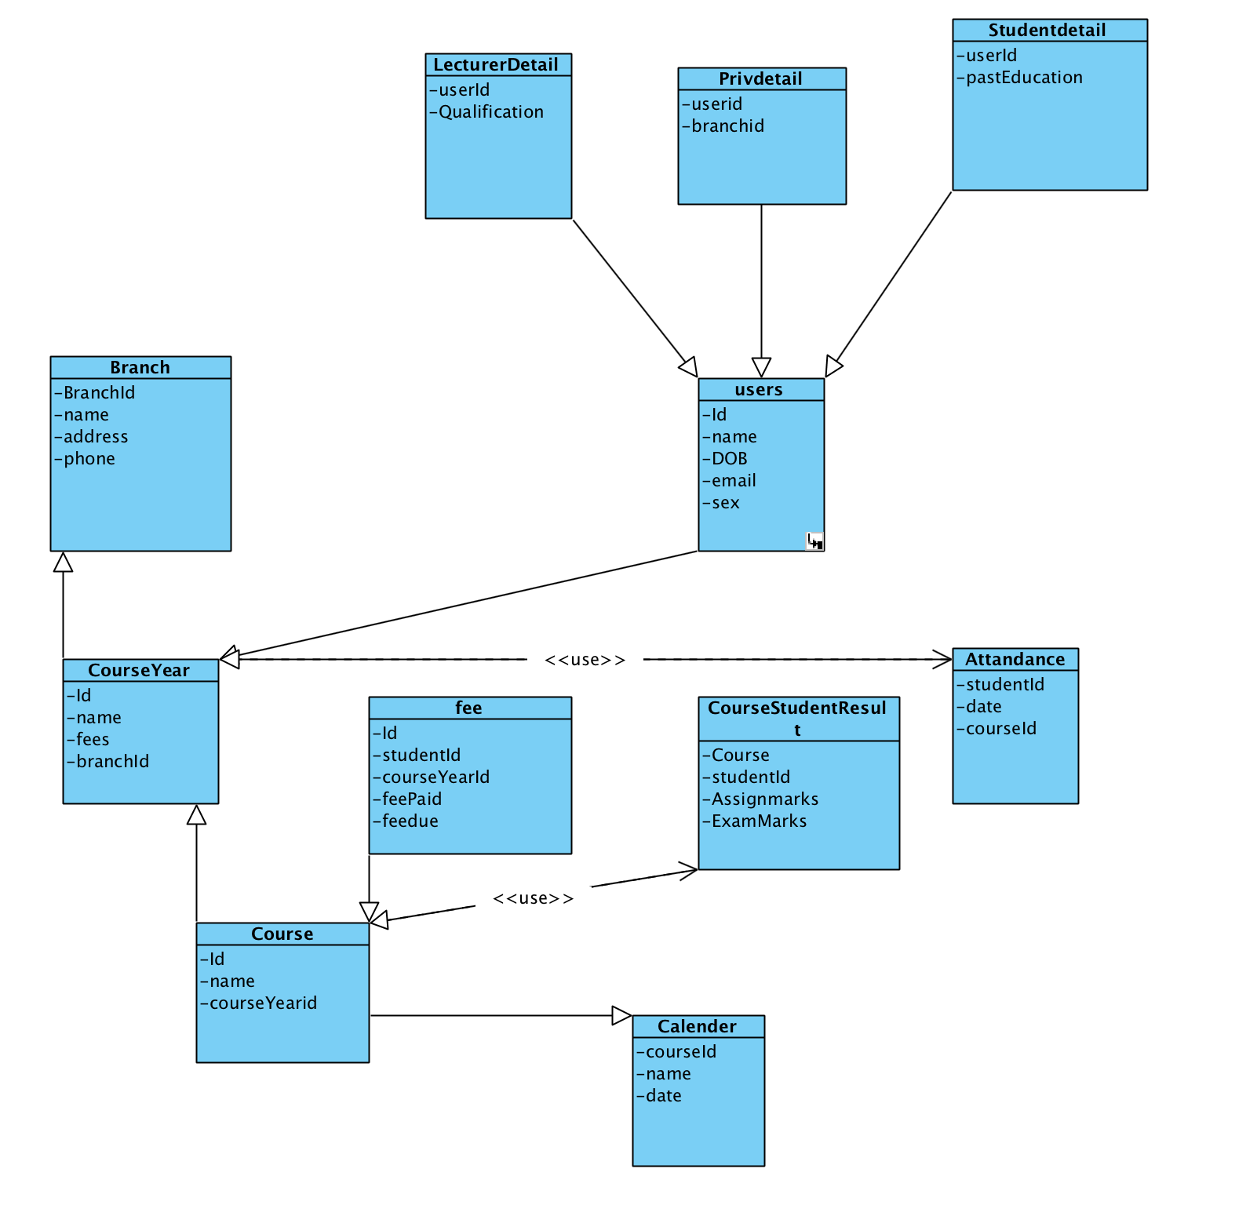

### Branches:

Branch Details Entity contain Branch details of the Virtual Global College (VGC).These are the entity.

1. ID
2. name
3. Address
4. Phone

### User Entity:

1. PrivId(unique or primary key)
2. branchID
3. name
4. dob
5. email
6. sex

### Student Detail:

1. userId
2. pastEducation

### Lecturer Detail:

1. userId
2. Qualification

### Attandance:

1. studentId
2. date
3. courseId

### Course

1. Id
2. Name
3. courseyearId

### CourseStudentResult

1. Course
2. Studentid
3. Assignment Marks
4. Examination Marks

### Course Year

1. Id
2. Name
3. Fees
4. BranchId

### Fees

1. Id
2. StudentId
3. courseYearId
4. feepaid
5. feedue

### calender

1. courseId
2. examdate
3. assignmentdate

Design View and Navigations:

Login form:

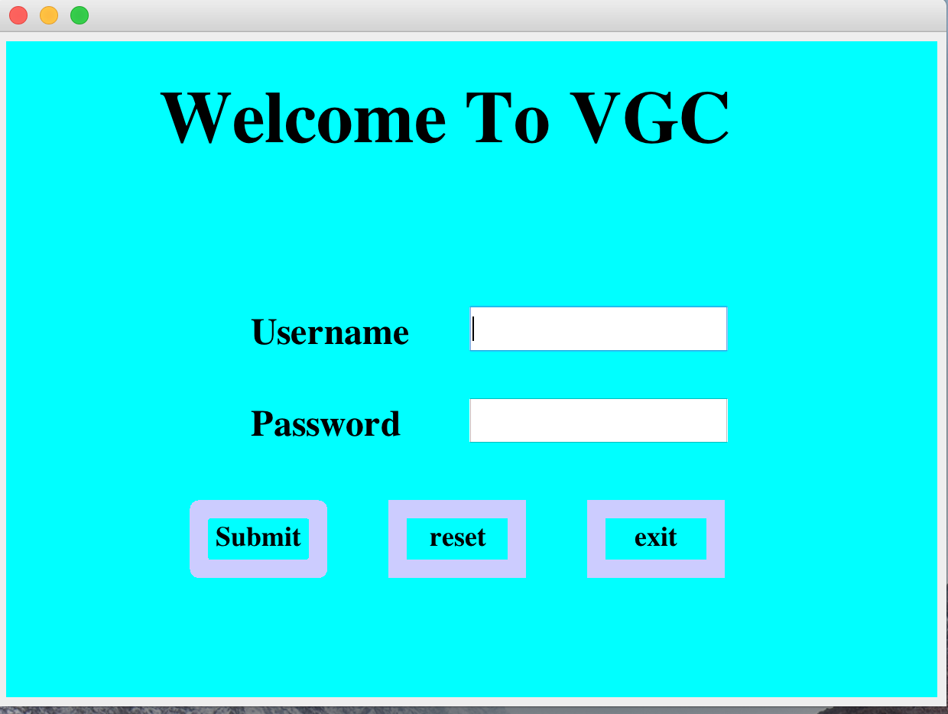

Login successful:

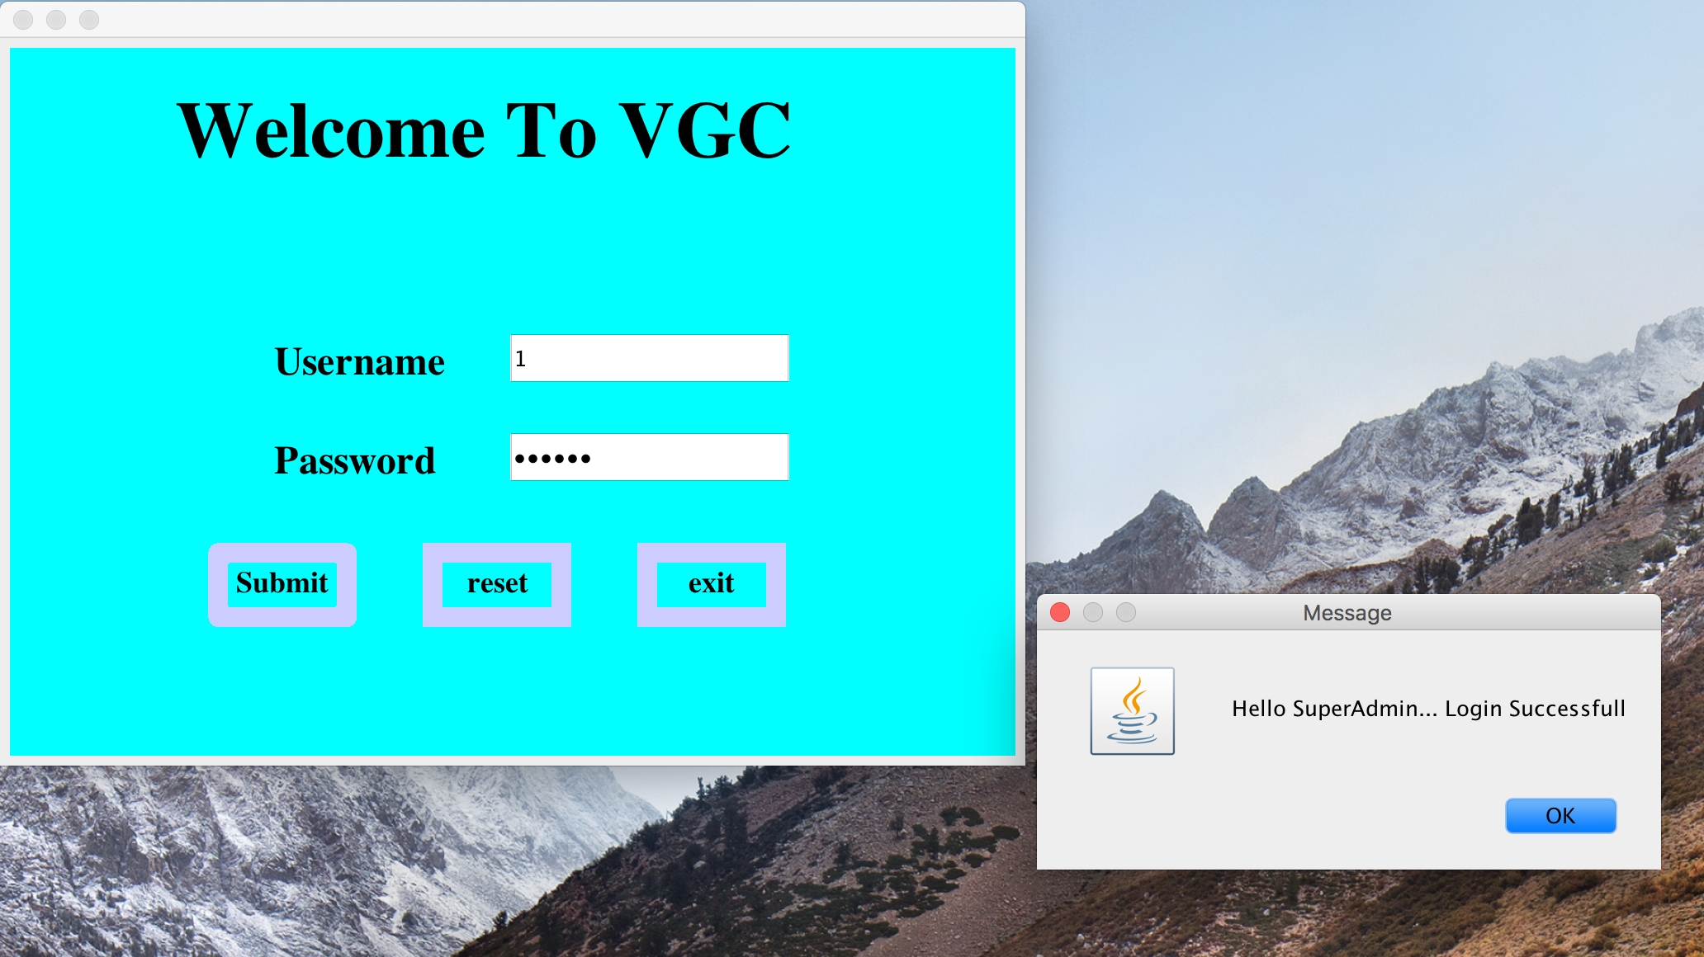

After login with the admin username and password, it is directed to add student, add lecturer, add admin. It is only done by the Super admin.

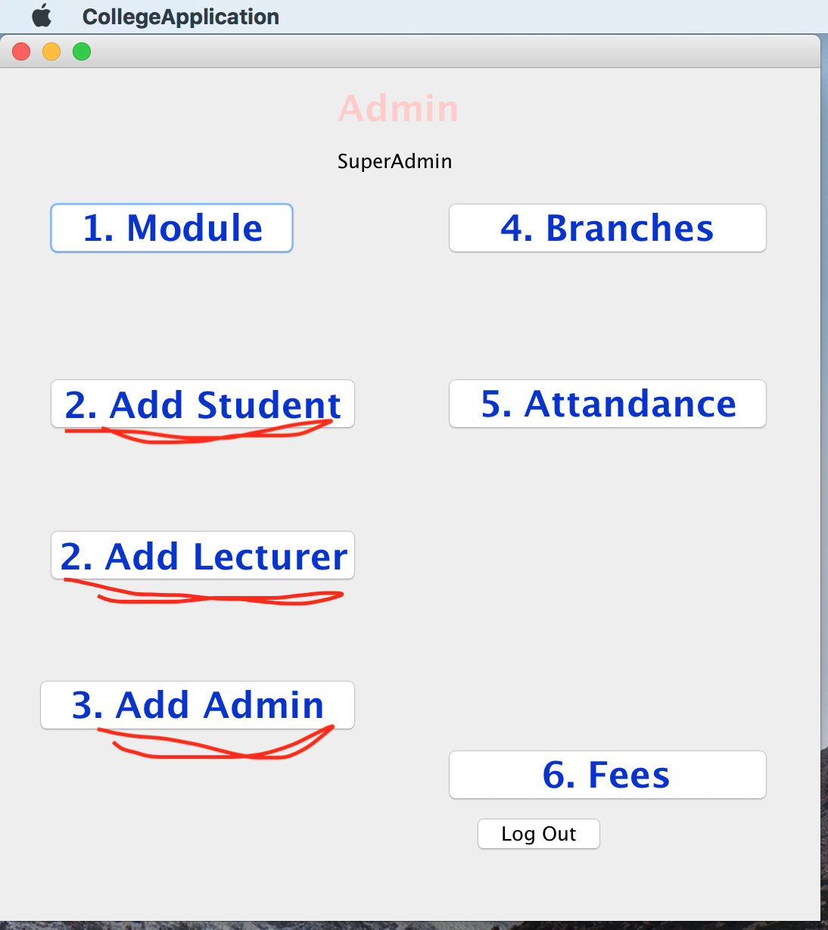

Registration Form pop up when adding student, Lecturer and admin.

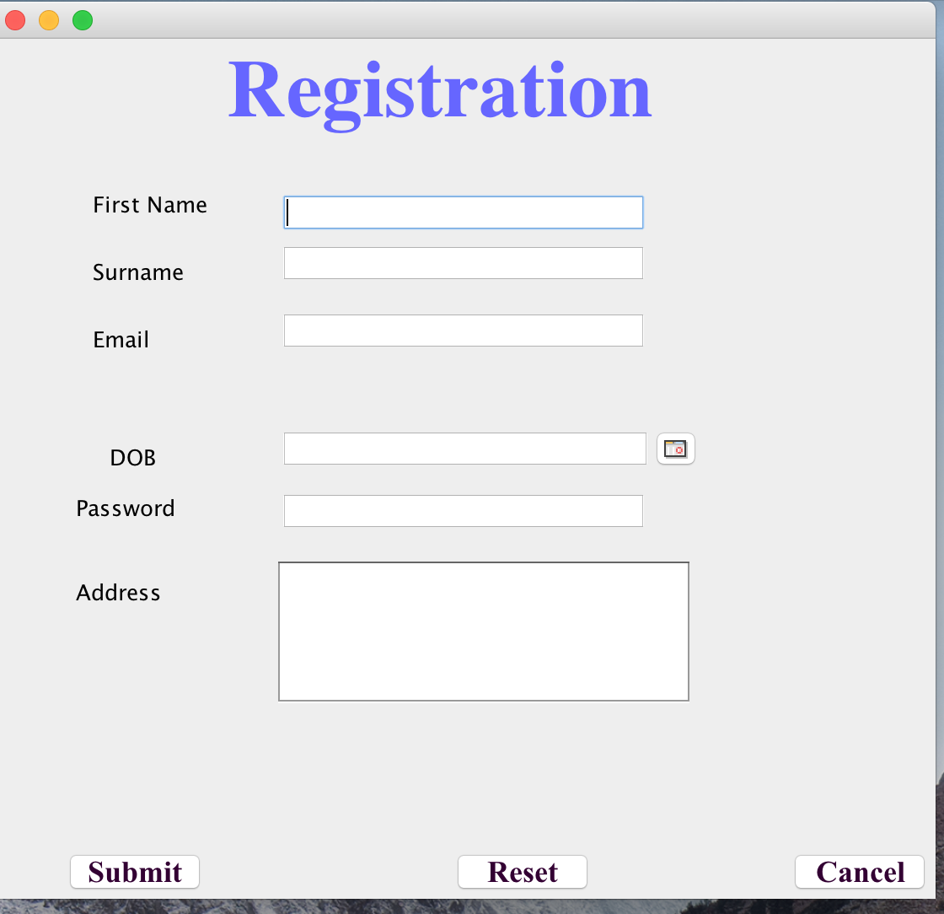

Filled and submitted form response:

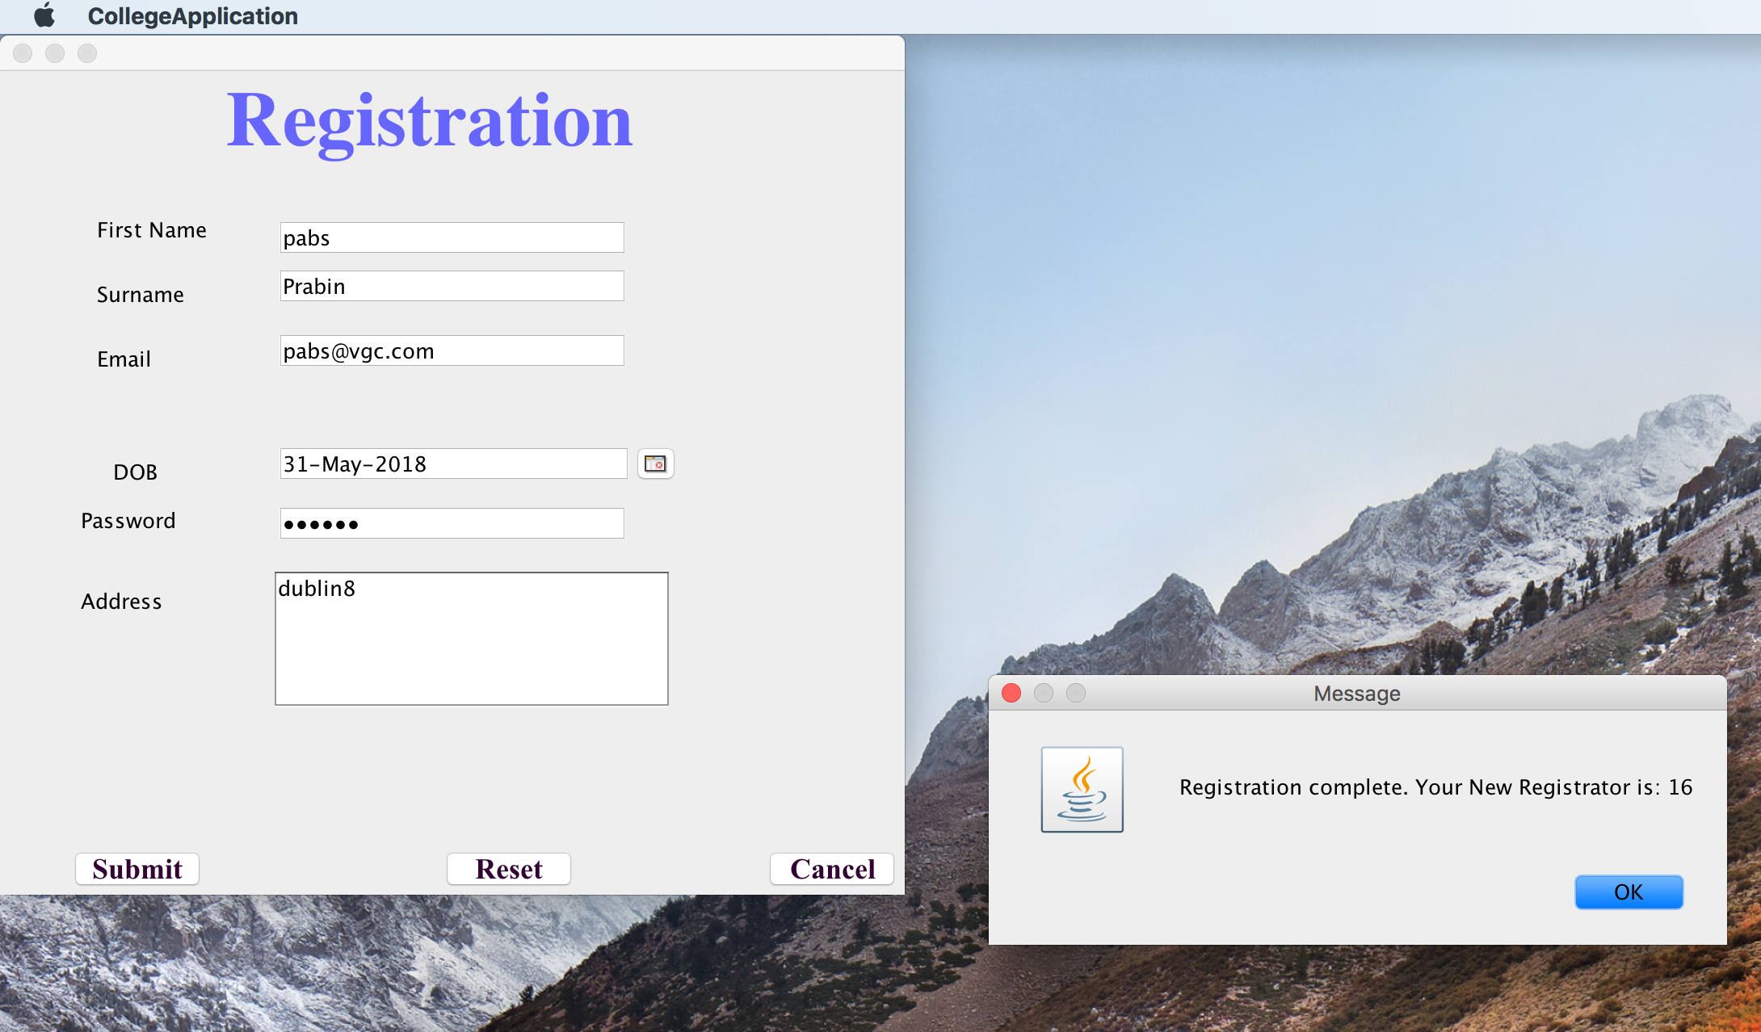

And can be used the registration no as username and the password written in the registration form will be the password for login. And admin page pop up and logging out of the admin again go to login page.

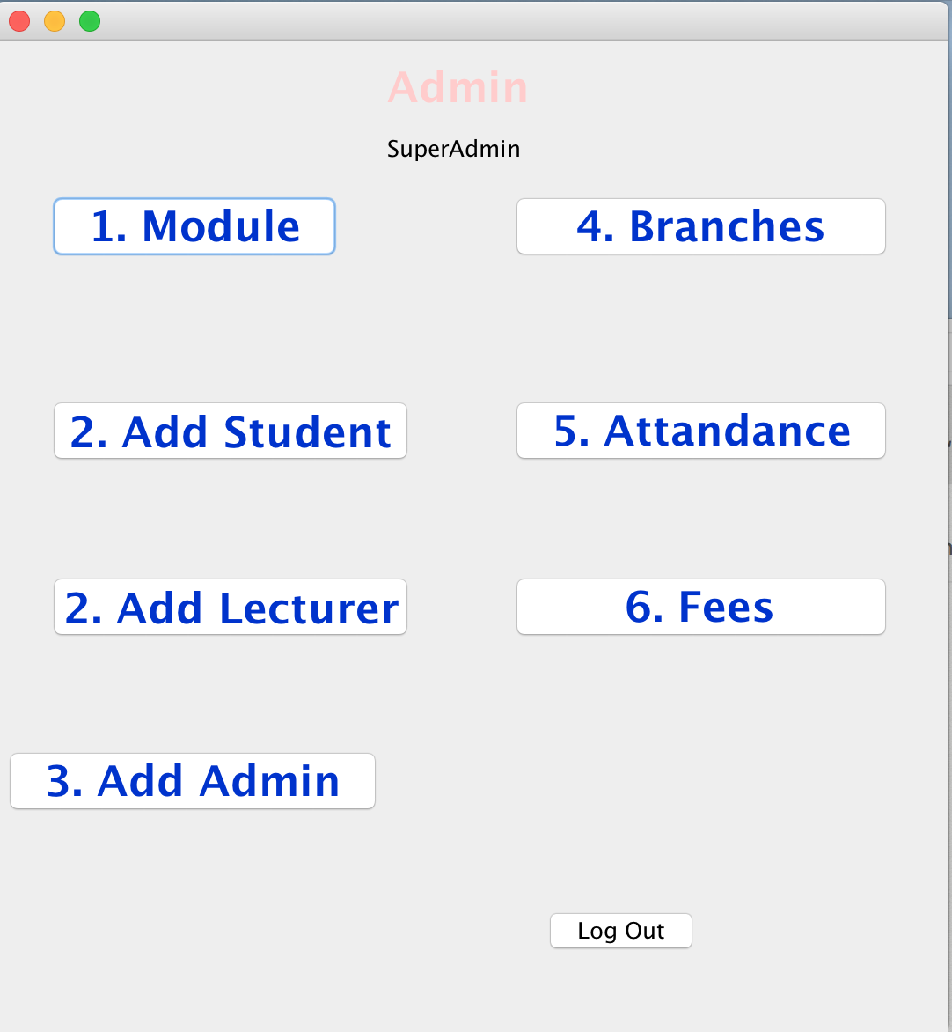

and after logout it pop up logging page/form



similarly logging in to the student following are the navigations:

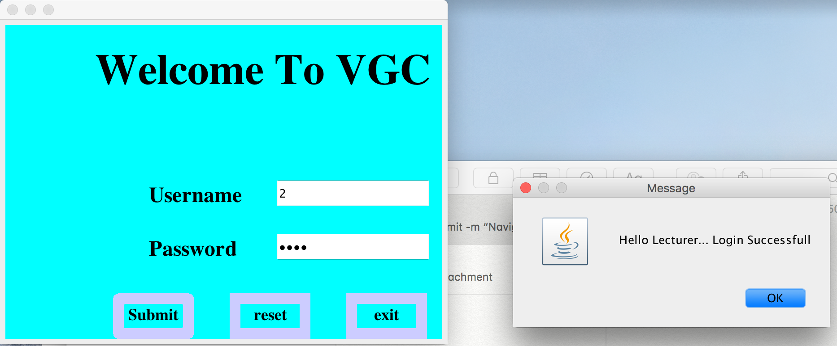

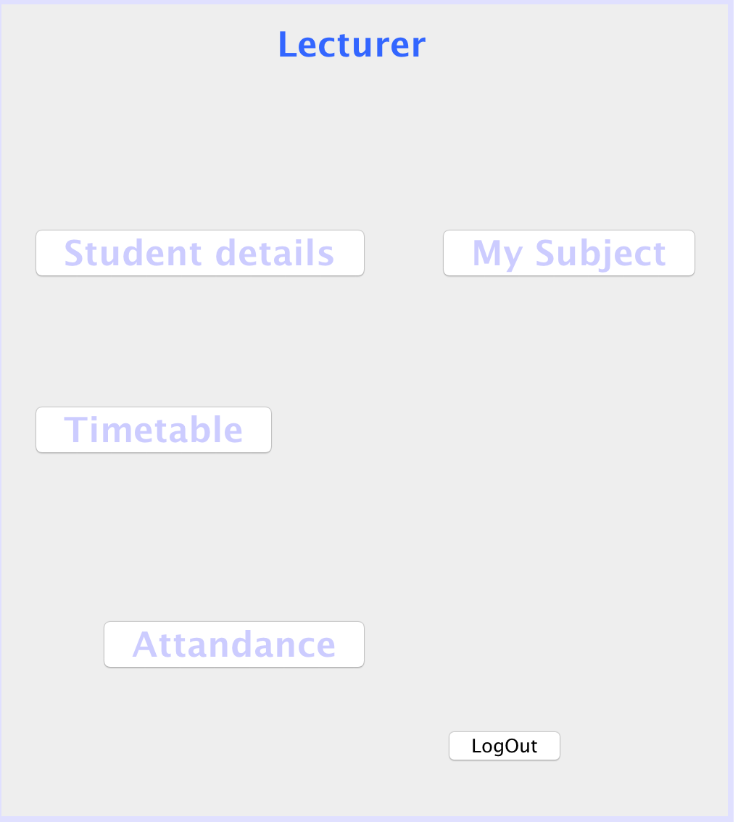

when logout it will go back to login form. Only the administer can add student, lecturer and admin too

Student details:

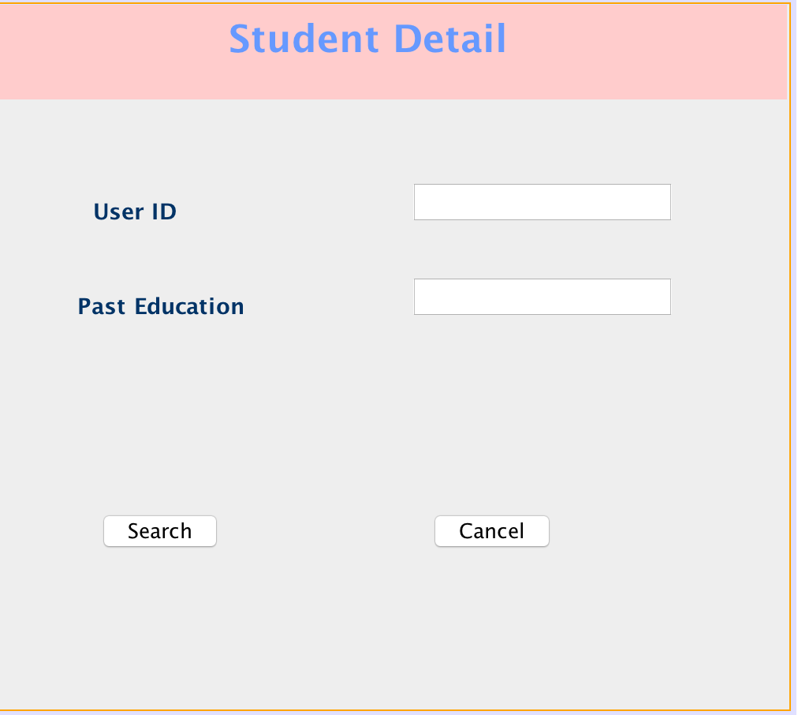

when cancel come back to lecture and logout from lecture come back to login form are as follows:





here are some screen sorts:

Timetable form:

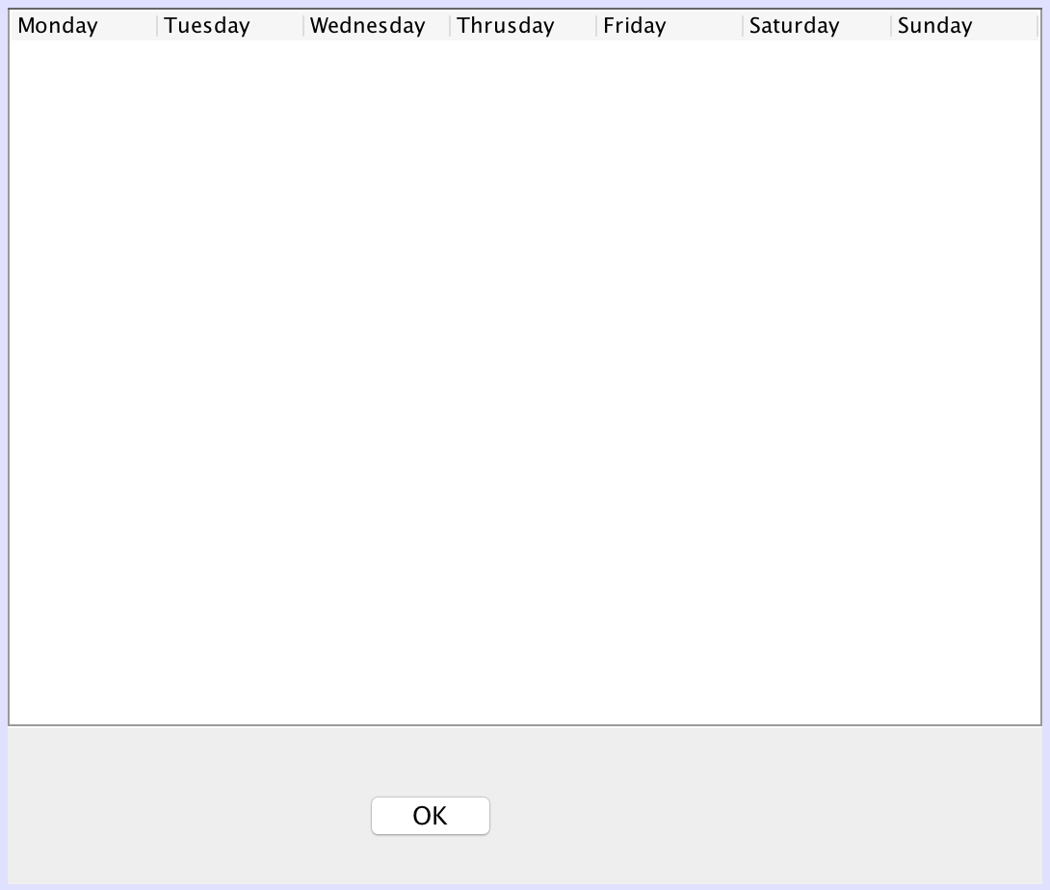

Modules:

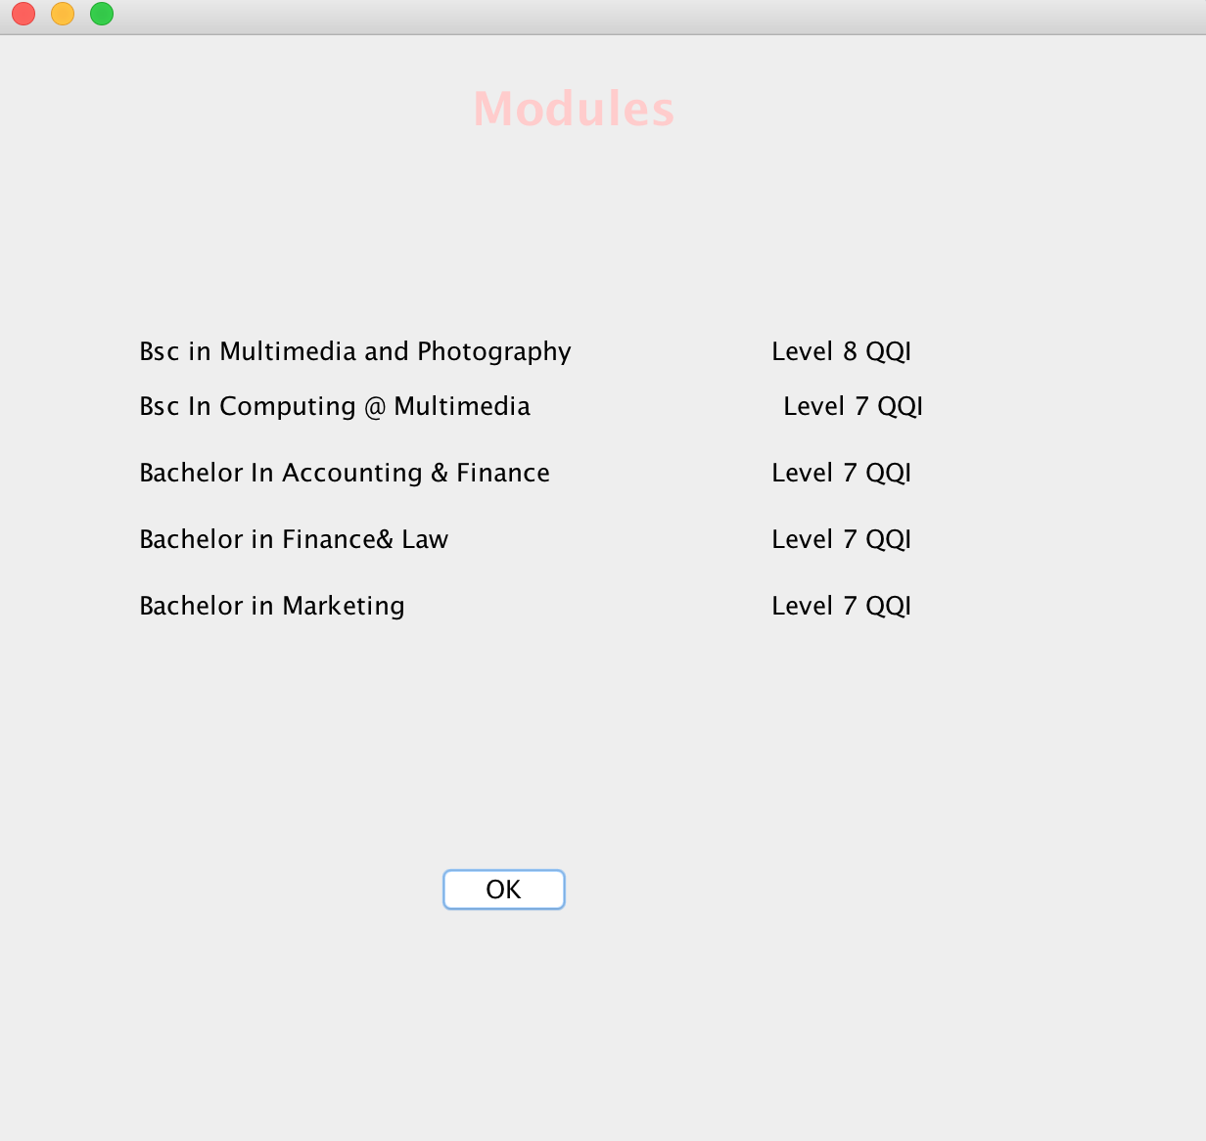

Attandance:

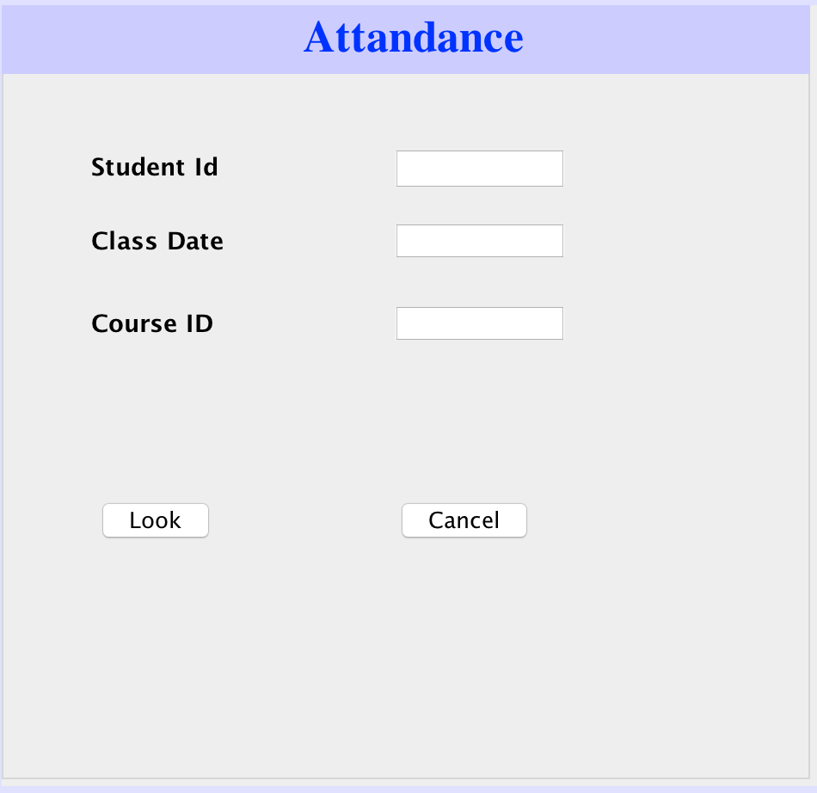

Calendar:

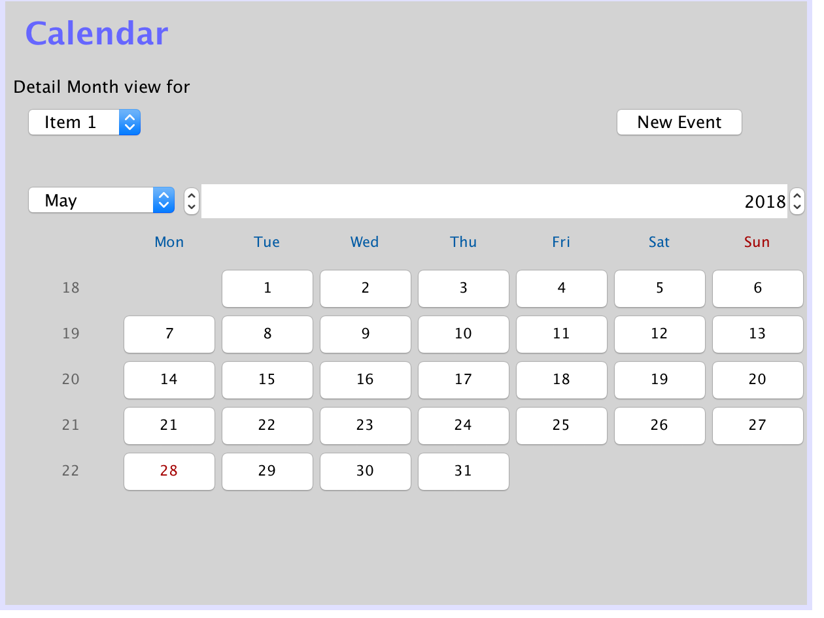

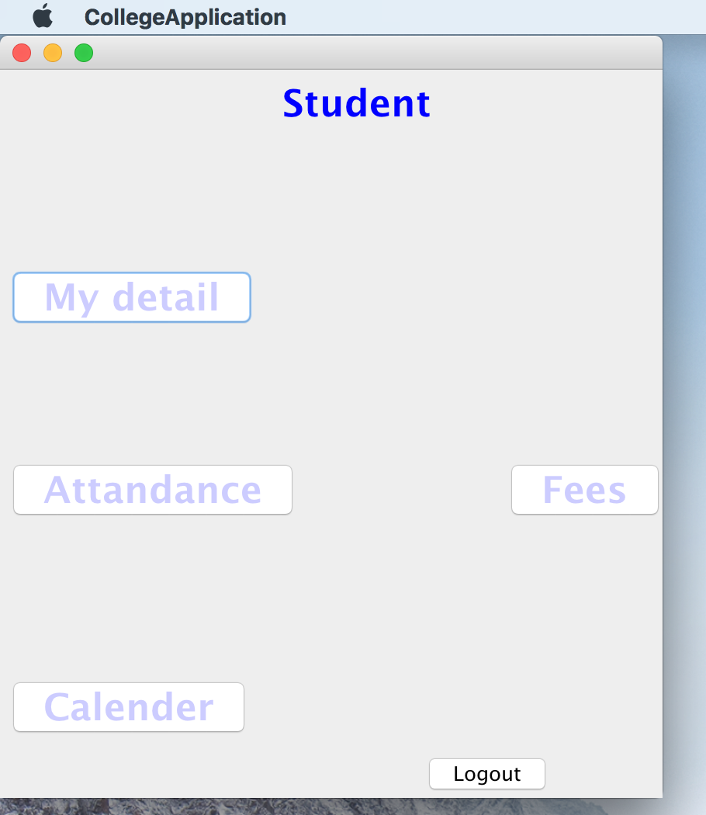

Profile:

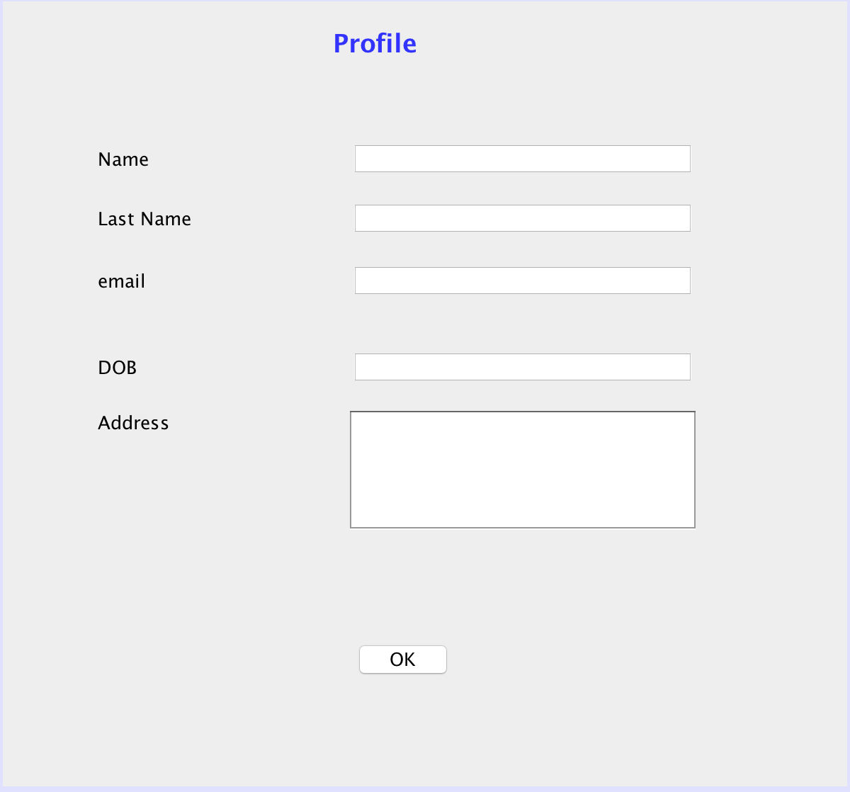

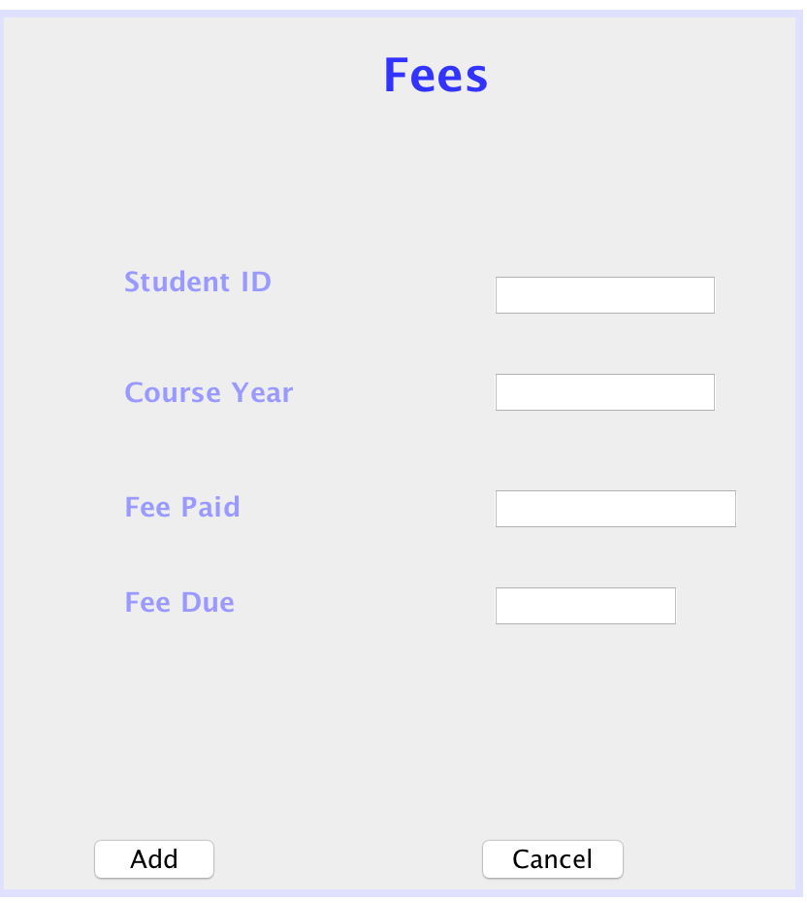

Student Result:



